James Chad Ballay

1. Using a device connected to a network, determine the following1:
   1. Device’s IP address(es).

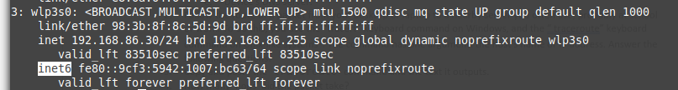

* 1. Does it use IPv4, IPv6, or both?

Both. Inet and Inet6. For example here is the output for the wireless interface.



* 1. Does the device use NAT? If so, list both the internal and external IP address2.

No

* 1. Does it use DHCP? If so, what's the DHCP Server?



* 1. Device's DNS server.

This one’s a bit tricky since I’m on a systemd system. 127.0.0.53 isn’t really real and instead it’s actually 192.168.86.1.





1. Follow the route of a packet from your desktop or laptop to a nearby server you often use, probably at school or work. To do this, you use the “tracert” keyboard command on Windows, and the “ traceroute” keyboard command on Unix-like systems3. The command has one argument: the host’s name or IP address. Answer the following questions:
   1. Copy and paste the traceroute command and the text it outputs.

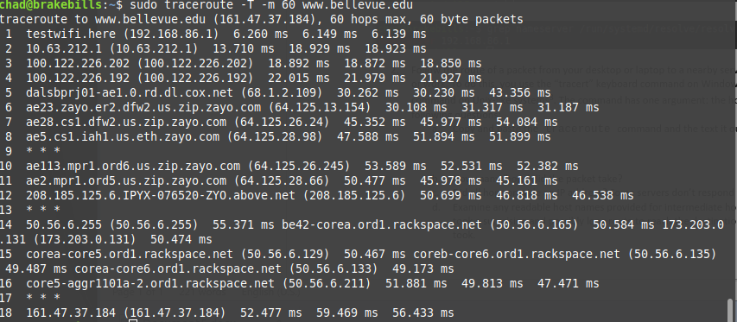

* 1. How many ‘hops’ did the packet take?

18

* 1. Did all hops provide an IP address? Some servers don’t respond to traceroute requests.

Hop 9, 13, and 17 failed to provide data.

* 1. Examine any readable host names provided for intermediate hops. Do any indicate that the packet took a surprising and possibly long route to reach the destination? If so, identify the distant hops it took.

Not really. Rackspace is a common enough compute/hosting provider that it doesn’t surprise me.